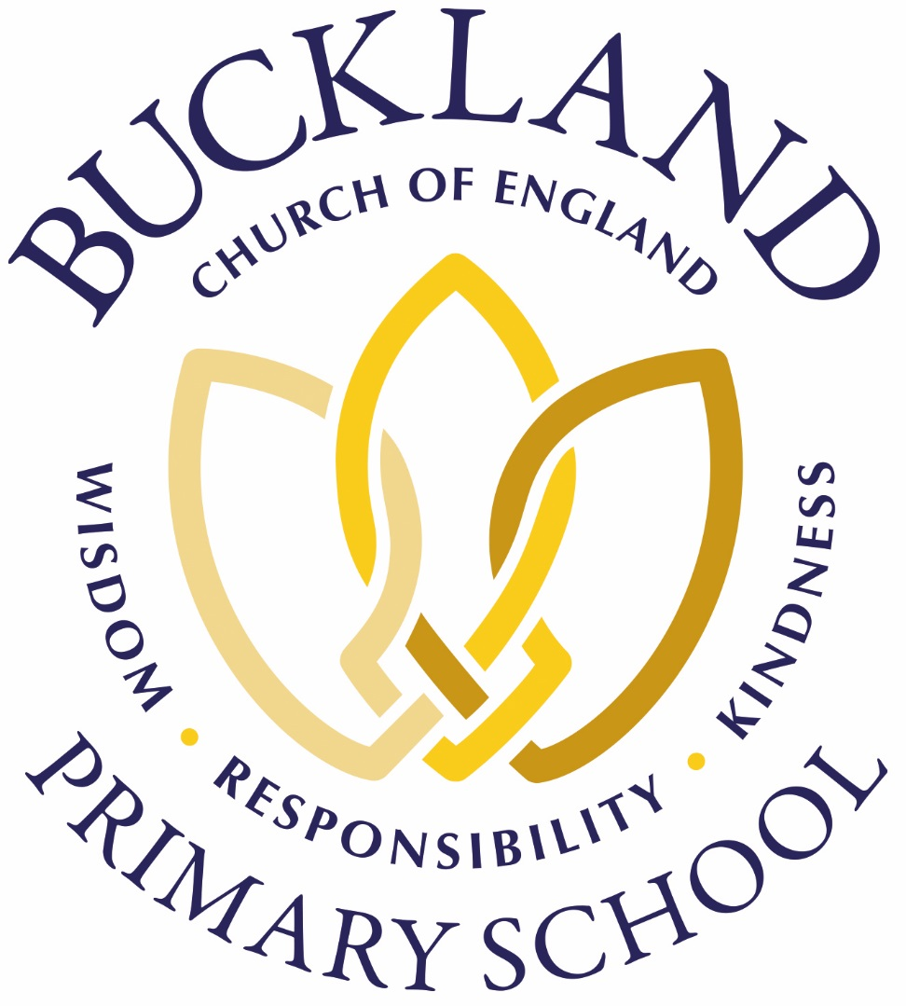
Oak Class (7th September – 11th September 2020)
Unity, Courage and Peace

Topic |  | English |  | Maths
This week, the children created a watercolour skyline picture of a part of the world of their choice, based on the Here We Are book. They used a range of techniques (which included helping each other) to improve their work which was really nice to see.  To help create the watercolour pictures, we all went outside and laid on the playground. We used some of our senses to inspire us once we were back in the classroom. |  | Oak class, along with the rest of the school, have embedded the book Here We Are to their English learning this week. The children have written an informal letter to Government regarding the welfare of animals post-lockdown as well as interpret the meaning of a poem linked with the story. Yesterday, the children created some fantastic messages on staying safe during this time by using a stop-go animation movie. In their own special way, they all added their own unique personalities which made many of the children smile and laugh out loud!  Challenge: Carrie and Nick are key characters in Carrie’s War. Read the first chapter (if you haven’t done so already at home). |  | Key vocabulary: partitioning, comparing, ordering, less than, greater than, rounding  At the beginning of the week, the children partitioned numbers in the millions and tens of millions in a variety of ways. From Tuesday onwards, the children compared and ordered a range of numbers (some which included decimals). They should all be able to explain how this is achieved. Today, the children started to round numbers to the nearest 10, 100 and 1000.  Challenge: Partition 7,456,392
Attention Children! |  | 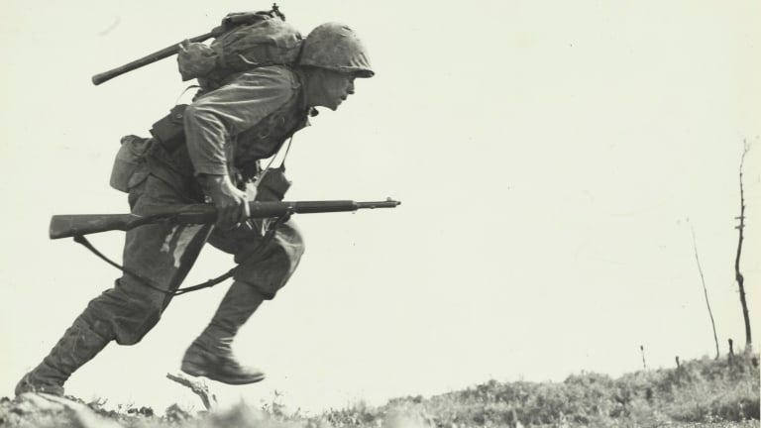 |  | Next week
Well done children on controlling your feelings and emotions at school this week. It is a very tricky time for everyone in the world but you have worked hard, collaborated when required and you seem to have enjoyed being back to school.  Have a great rest over the weekend and have some fun. Doing something which is fine can make you feel more positive about life. |  |  |  | Here are some activities we will be doing next week in Oak.  English – Letter writing (please bring your Carrie’s War book)  Maths – Rounding/Roman Numerals/  Art – Guernica sketching  Circle Time – Hopes and Dreams  Science – Describing the properties and changes of materials  PE – Tag Rugby and Football  Computing – Internet Safety

