Timeline
13,000 B.C. | 4500-3500 B.C. | 2300 B.C. | 1800 B.C. | 1200-800 B.C. | 800-700 B.C. | 700-500 B.C. | 100 B.C.
People make cave paintings | Farming starts to begin to spread and pottery is made | Start of the Bronze Age | The first copper mines are dug | Metal tools are made and used | Start of the Iron Age / The first hill forts are made | Iron is more commonly being used | Coins are made and used for the first time / Iron Age end with Romans in 43 AD

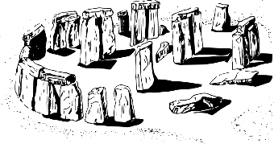

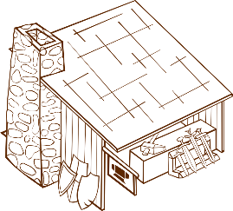
Stone Age to Iron Age
 | Key Vocabulary
The Stone Age
cave paintings | Artwork in caves dating back to the Ice Age.
jewellery | Late Stone Age people made it from shells, teeth and bones.
woolly mammoth | A now extinct animal roaming earth during the Ice Age.
nomadic | Early Stone Age people followed food sources and travelled.
Skara Brae | A stone-built Neolithic settlement in Scotland.
The Bronze Age
foundry | A place of work where metal castings are made.
jewellery | Wearing bronze items was a way to show how rich you were.
Stonehenge | A mysterious set of enormous stones built 3000 B.C. – 1500 B.C.
roundhouses | A circular house with a conical roof and wattle and daub walls.
weapons | Combining copper and tin to made hard weapons and armour.
The Iron Age
Celts | NW Europeans who used iron from 600 B.C. – 43 A.D.
hillforts | Small towns built on a hilltop surrounded by banks of soil and wooden walls to keep out enemies.
smithing | Blacksmiths would heat iron and create weapons / tools.
weapons | Swords, daggers and arrowheads were made of iron.
Stone Age - Palaeolithic to 10,000 BCE (end of the Ice Age) / Mesolithic to 4000 BCE / Neolithic to 2300 BCE
Early Stone Age Man was a hunter-gatherer, travelling around following food sources, setting up camps. Some lived in caves, although not many as this was dangerous. Scientists believe they had fires but used naturally occurring fire to bring to a campfire (e.g. a lightning strike) rather than making one by themselves. By the time it was the Neolithic Age, people stopped travelling and settled, becoming farmers and domesticating sheep, cattle and pigs. They learned how to soften leather to make warm, comfortable clothes and they used wool from sheep to spin, thread and weave into clothes. They built homes from wooden planks and covered it with wattle and daub. The roof was thatched using reeds. During this period, they also made clay pots for cooking, serving food and storing water. Huge tombs were made with dead remains.

Famous Bronze Age civilizations included the Shang Dynasty, Indus Valley, Ancient Egyptians and the Sumerians.
Bronze Age - 2300 BCE to 800 BCE
The mining of metals helped transform the world’s use of trade, weaponry pottery and jewellery. The creation of bronze, gold and copper items around this time signalled the end of the Stone Age and the start of the Bronze Age. These improved tools led to developments in farming and therefore larger productions able to feed growing cities. The invention of the wheel meant that animal drawn vehicles could drive along tracks and roads. The potter's wheel and textile production meant that better pottery and clothing could be produced.

Iron Age - 800 BCE to 43 CE
The Iron Age is a period of history when iron became the preferred metal of choice for making tools which is seen to have ended with the spread of the Roman Empire from 43 A.D. Iron was more readily available than bronze and was much easier to work with. This led to further improvements in farming and diet. During this time the Celts lived as an advanced Iron Age society. There were three main branches of Celts in Europe – Brythonic, Gaulic and Gaelic. Brythonic Celts (Britons) settled in England. Some people can still speak Celtic languages such as Welsh and Gaelic. Most Iron Age people worked and lived on small farms and their lives were governed by the changing of the seasons.

