BC | 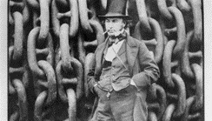  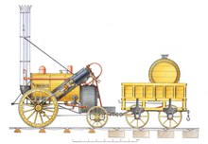  AD  Romans invade Britain AD 43 | | 1000 | | 1100  Stephenson designs  ‘The Rocket’  AD 1829 | 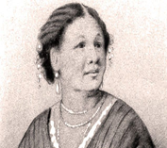  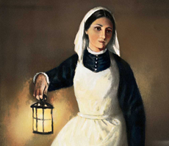  | 1200 | | 1300  Mary Seacole  in Crimea  AD 1855 | 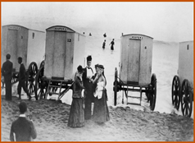  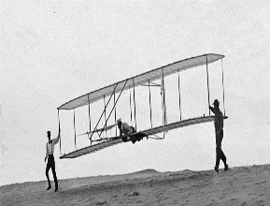  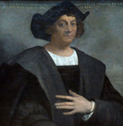  | 1400 | | 1500  Seaside holidays  Victorian times  AD 1837-AD 1901  Wright Brothers  First Flight  AD 1903 | 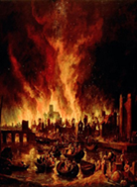  | 1600 | 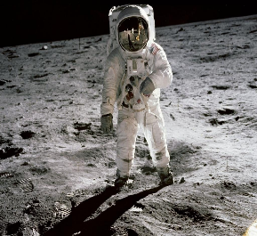  | 1700  | 1950  Great Fire of London AD 1666 | | 1800 | | 1900  Neil Armstrong  and Buzz Aldrin  Moon landing  AD 1969 | | 2000  | 2000
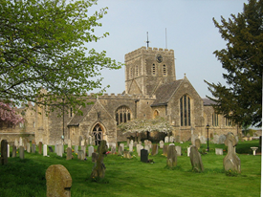

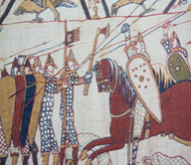
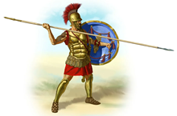
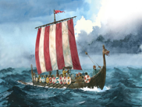

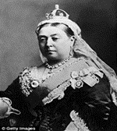
St Mary’s Church, Buckland built 1300s

Brunel starts
developing the
railways AD 1833
Florence Nightingale
in Crimea
AD 1854
Florence Nightingale
in Crimea
AD 1854
| 1850
| 1800
| 1900
Battle of Hastings
AD 1066
Gun Powder Plot
AD 1605
Queen Victoria on the throne: AD 1837-AD 1901
History Timeline
Christopher Columbus discovers America
AD 1492
Birth of
Jesus Year 0
Vikings invade Britain AD 787

1900 Onwards

