Buckland Church of England Primary School

Calculation Policy
Contents  Introduction ---------------------------------------------------------------------- Page 3  Addition and Subtraction  Early Years Foundation Stage ------------------------------------------------- Pages 4-5  Year 1 ----------------------------------------------------------------------------- Pages 6-7  Year 2 ----------------------------------------------------------------------------- Pages 8-9  Year 3 ----------------------------------------------------------------------------- Pages 10-11  Year 4 ----------------------------------------------------------------------------- Pages 12-13  Year 5 ----------------------------------------------------------------------------- Pages 14-15  Year 6 ----------------------------------------------------------------------------- Pages 16-17  Multiplication and Division  Early Years Foundation Stage ------------------------------------------------- Pages 18-19  Year 1 ----------------------------------------------------------------------------- Pages 20-21  Year 2 ----------------------------------------------------------------------------- Pages 22-23  Year 3 ----------------------------------------------------------------------------- Pages 24-25  Year 4 ----------------------------------------------------------------------------- Pages 26-27  Year 5 ----------------------------------------------------------------------------- Pages 28-29  Year 6 ----------------------------------------------------------------------------- Pages 30-31 | Introduction  “The emergence of meaning is a collective endeavour, rather than an individual one. The individual learning and meaning-making is a consequence of being part of a community that is striving toward reaching a collective understanding, through joint activity, dialogue.”  Mike Askew, 2012  The following calculation policy has been devised to meet the requirements of the 2014 National Curriculum for the teaching and learning of mathematics, and is also designed to give pupils a consistent and smooth progression of learning in calculations across the school. Please note that early learning in number and calculation in Reception follows the Development Matters EYFS document, and this calculation policy is designed to build on progressively from the content and methods established in the Early Years Foundation Stage.  This policy exemplifies a recommended progression through the four operations, beginning in the Early Years Foundation Stage and carrying on to Year 6 and includes a selection of mental strategies.Whereas the policy details expectations for given year groups, these reflect age-related expectations and, therefore, teachers need to make reference to prior or later stages in the progression of calculation to meet the needs of the children. It is intended to be used to support planning and teaching.  In the Buckland Church of England Primary School, it is believed that calculation, as well as other areas of maths, should be taught from the pupils’ starting points. Through carefully planned learning which allows pupils to manipulate and explore physical resources and visual models, and engage in high quality talk internally, and with peers and adults, they will develop meaningful insights into number and calculation.  Formal algorithms should not be rushed. Learning flexible efficient methods will be the prime aim for all children until they possess the prerequisite knowledge and experience that will ensure successful application.

Addition and Subtraction: EYFS

Mental Maths Objectives:
Recall | Mental Calculation Skills | Mental Strategies
- Can count reliably to at least 20. | - Can find one more or one less than a given number.  - Can estimate how many objects they can see and check by counting.  - Use the language of ‘more’ and ‘fewer’ to compare two sets of objects. | - Through games, songs and practical activities children begin to use vocabulary of addition and subtraction.  - Use fingers and practical equipment to combine two sets and begin to count on.

Addition | Subtraction
Progression of calculation  U+U (aggregation: combining objects)  1 more than a given number up to 20.  U+U (augmentation: counting on)  Written methods  • Make a record in counters, numicon, pictures or marks of addition activities.  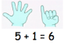  - Teacher demonstrates how to record on a number line and using numbers and symbols including + and =  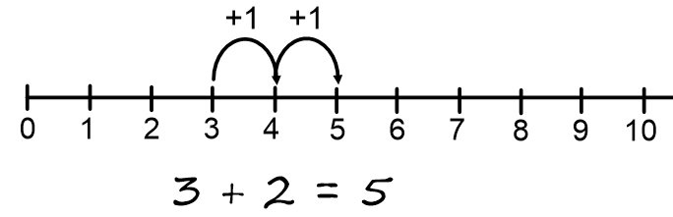  - Children jump forwards along the number line using a finger and, if ready, record using number lines and symbols.  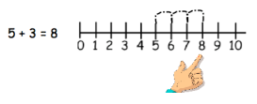 | Progression of calculation  U – U (take away structure)  1 less than a given number: First from 1 – 5, moving to 1 – 10 and finally 1- 20  U – U (comparison structure, “how many more …; “how many less …”)  Written methods  • Make a record in counters, numicon, words, or fingers of subtraction activities already carried out. Children progress to record in numbers and symbols.  e.g. 6 – 3 = 3  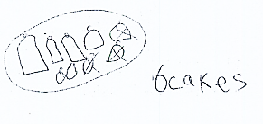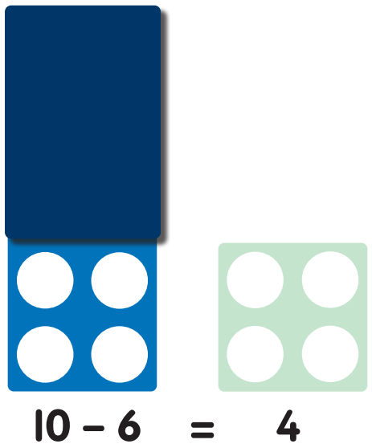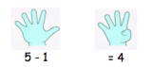  - Children use number lines, tracks and numicon shapes to find one less and support with counting back.  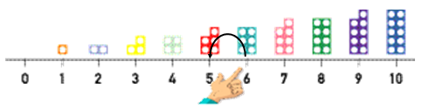  - Teacher demonstrates how to record counting back on a number line.  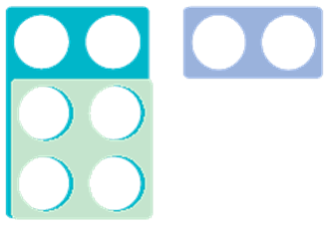  - Children use objects and numicon to help them to compare objects and state how many more or less. E.g. “Six is two more than four.”

Addition and Subtraction: Year 1

Mental Objectives
Recall | Mental Calculation Skills | Mental Strategies
- number pairs with a total of 10, e.g. 3 + 7, or what to add to a single-digit number to make 10, e.g. 3 + □ = 10  - addition facts for totals to at least 5, e.g. 2 + 3, 4 + 3  - addition doubles for all numbers to at least 10,  e.g. 8 + 8 | - add or subtract a pair of single-digit numbers,  e.g. 4 + 5, 8 – 3  - add or subtract a single-digit number to or from a teens number, e.g. 13 + 5, 17 – 3  - add or subtract a single-digit to or from 10, and add a multiple of 10 to a single-digit number, e.g. 10 + 7,  7 + 30  - add near doubles, e.g. 6 + 7
  • reorder numbers when adding, e.g. put the larger number first
  • count on or back in ones, twos or tens
  • partition small numbers, e.g. 8 + 3 = 8 + 2 + 1
  • partition and combine tens and ones
  • partition: double and adjust, e.g. 5 + 6 = 5 + 5 + 1

Addition | Subtraction
Progression of calculation  U+U (counting on)  U+U crossing 10  U+U crossing 10 using number facts to bridge  Teens + U within 20  U + multiple of 10  1 more than any given number to 100  Written methods  - Children are encouraged to create representations of the number system using pictures and apparatus to help them. Equals (=) is understood as denoting equivalence.  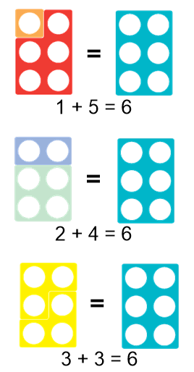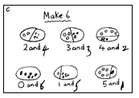  - Children begin to use numbered lines to support their own calculations when counting on in units.  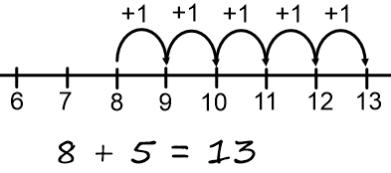  - Children begin to bridge through 10 with help from hundred squares, numicon or bead strings.  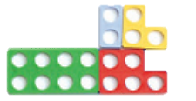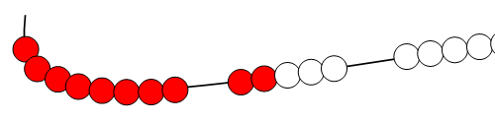 | Progression of calculation  U – U (take away structure)  U – U (comparison and difference structures)  Numbers to 20 – U  Numbers to 20 – U (crossing ten)  Any subtraction from 20  Written methods  - Counting back in units along a numberline  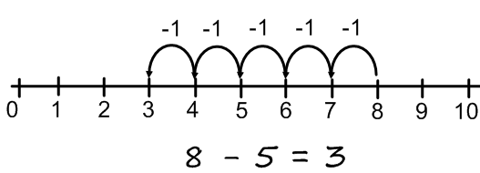  - Using a number line children count on for difference and comparison structures. (Children should make use of visual and practical resources to support understanding).  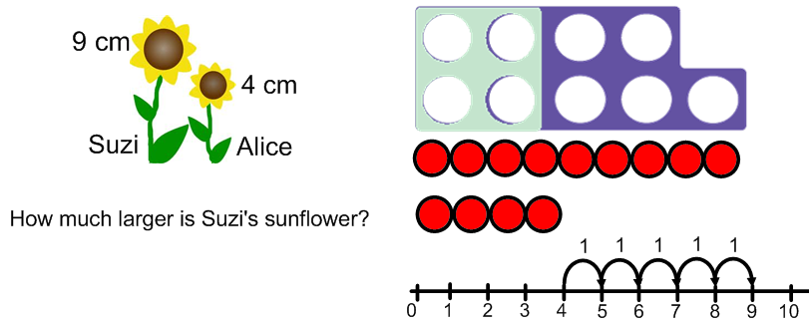  - Children use bead strings, numicon or hundred squares to help to bridge through 10 when counting back and support with known facts. (See Year 1 addition)

Addition and Subtraction: Year 2
Mental Objectives
Recall | Mental Calculation Skills | Mental Strategies
- addition and subtraction facts for all numbers up to at least 10, e.g. 3 + 4, 8 – 5  - number pairs with totals to 20  - all pairs of multiples of 10 with totals up to 100, e.g. 30 + 70, or 60 += 100  - what must be added to any two-digit number to make the next multiple of 10, e.g. 52 + ◻ = 60  - addition doubles for all numbersto 20, e.g. 17 + 17 and multiples of 10 to 50, e.g. 40 + 40 | - add or subtract a pair of single-digit numbers, including crossing 10, e.g. 5 + 8, 12 – 7  - add any single-digit number to or from a multiple of 10, e.g. 60 + 5  - subtract any single-digit number from a multiple of 10, e.g. 80 – 7  - add or subtract a single-digit number to or from a two-digit number, including crossing the tens boundary, e.g. 23 + 5, 57 – 3, then 28 + 5, 52 – 7  - add or subtract a multiple of 10 to or from any two-digit number, e.g. 27 + 60, 72 – 50  - add 9, 19, 29, … or 11, 21, 31, …  - add near doubles, e.g. 13 + 14, 39 + 40 | - reorder numbers when adding  - partition: bridge through 10 and multiples of 10 when adding and subtracting  - partition and combine multiples of tens and ones  - use knowledge of pairs making 10  - partition: count on in tens and ones to find the total  - partition: count on or back in tens and ones to find the difference  - partition: add a multiple of 10 and adjust by 1  - partition: double and adjust

Addition | Subtraction
Progression of Calculation  TU + U (not crossing 10s)  TU + T (not crossing 100)  TU + U (bridging through 10)  TU + ‘teens number’  TU + TU not crossing tens.  U + U + U …  Written Methods  - Children use visual resources and apparatus to help them to move from numbered lines to empty number lines, (numicon, Cuisenaire and beaded tracks). First by counting in single tens and units, then using known facts  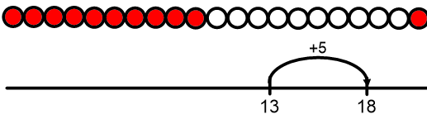  (e.g. 13 + 5 = 8):  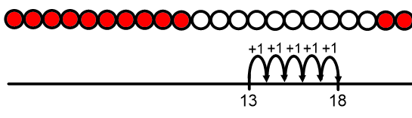  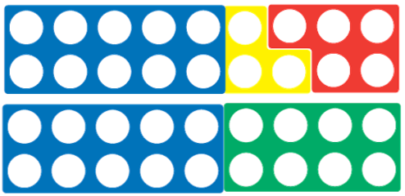  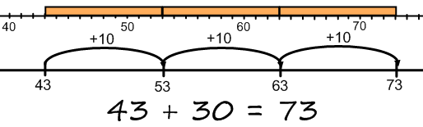  - Children continue to use visual resources to reinforce bridging through ten (see year 1) and use known number facts to record on an empty number line  (e.g. 5 + 7 = 7 + 3 + 2 = 12)  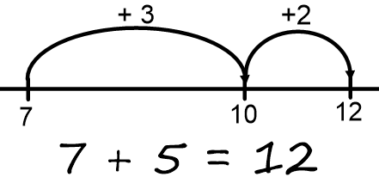  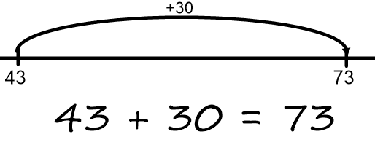  - When adding 2-digit numbers children learn to partition both and recombine.  34 + 23 =  30 + 20 = 50 4 + 3 = 7  50 + 7 = 57 | Progression of Calculation  TU – U not crossing 10s  TU – U crossing 10s  TU – T  TU – TU (counting back)  TU – TU (counting on)  Written Methods  - Children use visual resources and apparatus to help them to move from numbered lines to empty number lines, (numicon, Cuisenaire and beaded tracks). First by counting on or back in single tens and units, then using known facts to bridge through 10s.  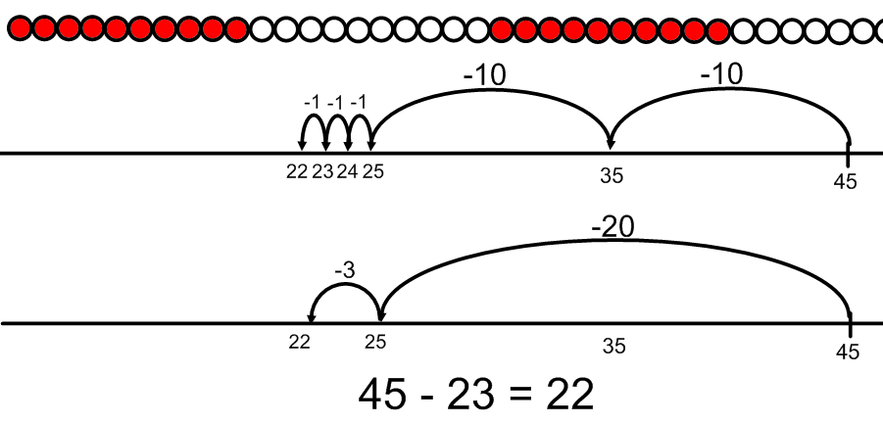  - Children continue to use counting on to model difference and comparison structures.  - Children understand that counting on is a method of subtraction by considering the beginning of the number line being taken away.  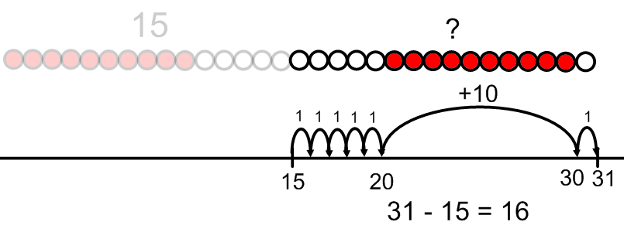  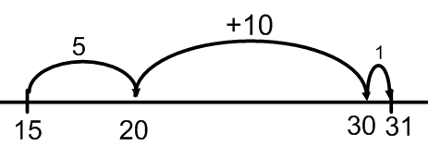  - Children identify when counting on is a better strategy and record on numberline (e.g. when numbers are close together or they are subtracting from a near multiple of 10). Again, children begin counting on in single steps before consolidating these using known facts and practical equipment if needed.

Addition and Subtraction:Year 3
Mental Objectives
Recall | Mental Calculation Skills | Mental Strategies
- addition and subtraction facts for all numbers up to at least 10, e.g. 3 + 4, 8 – 5  - number pairs with totals to 20  - all pairs of multiples of 10 with totals up to 100, e.g. 30 + 70, or 60 +□= 100  - what must be added to any two-digit number to make the next multiple of 10, e.g. 52 +□= 60  - addition doubles for all numbers to 20, e.g. 17 + 17 and multiples of 10 to 50, e.g. 40 + 40 | - add or subtract a pair of single-digit numbers, including crossing 10,  e.g. 5 + 8, 12 – 7  - add any single-digit number to or from a multiple of 10, e.g. 60 + 5  - subtract any single-digit number from a multiple of 10, e.g. 80 – 7  - add or subtract a single-digit number to or from a two-digit number, including crossing the tens boundary, e.g. 23 + 5, 57 – 3, then 28 + 5, 52 – 7  - add or subtract a multiple of 10 to or from any two-digit number, e.g. 27 + 60, 72 – 50  - add 9, 19, 29, … or 11, 21,31, …  - add near doubles, e.g. 13 + 14, 39 + 40 | - reorder numbers when adding  - partition: bridge through 10 and multiples of 10 when adding and subtracting  - partition and combine multiples of tens and ones  - use knowledge of pairs making 10  - partition: count on in tens and ones to find the total  - partition: count on or back in tens and ones to find the difference  - partition: add a multiple of 10 and adjust by 1  - partition: double and adjust

Addition | Subtraction
Progression of Calculation  TU + TU (bridging through 10s, not crossing 100)  TU + TU (crossing 100)  HTU + TU  HTU + HTU  Written Methods  - Children use the empty number line to count on in tens and units including bridging through tens.  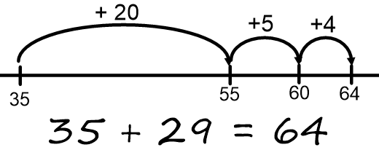  - Children use the empty number line to model flexible mental strategies. For example, adding near multiples of 10 by adding 10s and then adjusting.  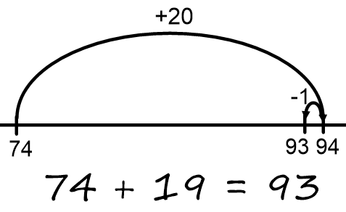  - When adding 2- and 3-digit numbers, children should be allowed opportunity to record their own jottings to support their understanding.  E.g.  46 + 87 = 87 + 40 + 6  Or  40 + 80 = 120  6 + 7 = 13  - Through exploration of place value blocks and cards, children begin to use expanded methods of column addition for larger numbers.  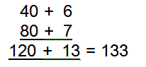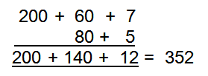 | Progression of Calculation  Written Methods  - Children continue to use the empty number line to subtract increasingly large numbers by:  - Taking away in convenient and partitioned steps. E.g. 246 – 87  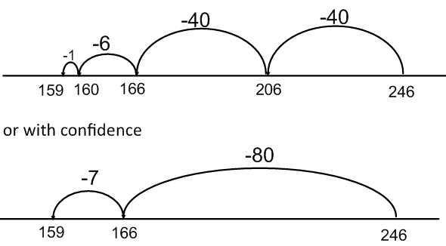  - Counting on from the smaller number to the larger using known facts.  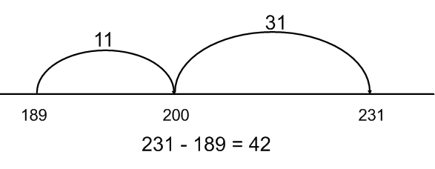  - Children will use the empty number line to show their thinking and understanding of other flexible mental methods. E.g. taking away near multiple of ten and compensating.  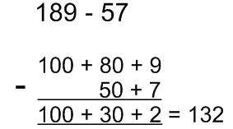  - Through exploration of place value blocks and cards, children begin to use expanded methods of column subtraction. E.g. 189 – 57  Children will subtract the units first.  This calculation should be read as take 6 from 1. Exchange should be modelled using place value equipment and children are to use the vocabulary “exchange”.  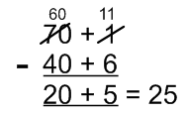
  Empty Number Line  HTU – TU (crossing hundreds)  HTU – HTU | Expanded Column Method  TU – TU and HTU - HTU  Stage 1: no exchange  Stage 2: Exchange T to U  Stage 3: Exchange H to T

Addition and Subtraction: Year 4
Recall | Mental Calculation Skills | Mental Strategies
- sums and differences of pairs of multiples of 10, 100 or 1000  - addition doubles of numbers 1 to 100, e.g. 38 + 38, and the corresponding halves  - what must be added to any three-digit number to make the next multiple of 100, e.g. 521 +□= 600  - pairs of fractions that total 1 |  | - count on or back in hundreds, tens and ones  - partition: add tens and ones separately, then recombine  - partition: subtract tens and then ones, e.g. subtracting 27 by subtracting 20 then 7  - subtract by counting up from the smaller to the larger number  - partition: add or subtract a multiple of 10 and adjust,  e.g. 56 + 29 = 56 + 30 – 1, or 86 – 38 = 86 – 40 + 2  - partition: double and adjust  - use knowledge of place value and related calculations, e.g. work out 140 + 150 = 290 using 14 + 15 = 29  - partition: count on or back in minutes and hours, bridging through 60 (analogue and digital times)
  - add or subtract any pair of two-digit numbers, including crossing the tens and 100 boundary, e.g. 47 + 58, 91 – 35
  - add or subtract a near multiple of 10, e.g. 56 + 29, 86 – 38
  - add near doubles of two-digit numbers, e.g. 38 + 37
  - add or subtract two-digit or three-digit multiples of 10, e.g. 120 – 40, 140 + 150

Addition | Subtraction
Progression of Calculation  HTU + HTU (crossing 1000)  £U.t h + £U.t h  £TU.t h + £TU.t h  Written methods  - Children continue to use the number line to count on. They do this by partitioning the smaller number.  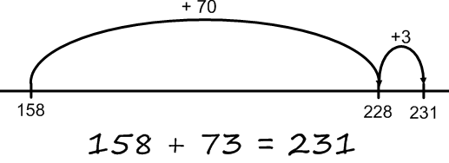  - Children continue to use expanded methods until they are ready to move to more compact methods. Knowledge of carrying is carefully considered is done so below the line to avoid confusion with subtraction using words ‘carry ten’ or ‘carry one more hundred’, not ‘carry one’.  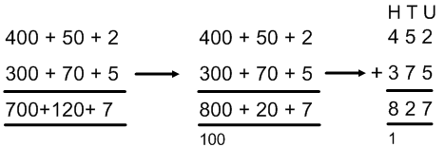  Revert to expanded methods for children who develop misconceptions or make many errors.  Column method is used to support the addition of decimals in the context of money. | Progression of Calculation  HTU – TU; HTU - HTU  Stage 4: exchange of T to U and H to T  Stage 5: Handling of zero place holders, e.g.  £U. t h - £U. t h  Written methods  - Children continue to use the empty number line to model their understanding of contextual problems and of flexible mental methods (see year 4 mental objectives).  - Children continue to use expanded methods until they are ready to move onto more compact methods of recording.  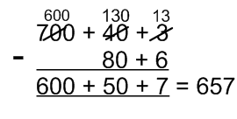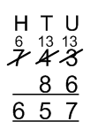  - Children use the expanded method to add decimals in the context of money paying close attention to place value.  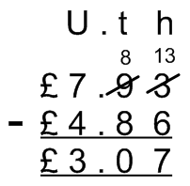
  470  -142 | 700  -485 | 604  -347

Addition and Subtraction: Year 5
Mental Maths Objectives
Recall | Mental Calculation Skills | Mental Strategies
- sums and differences of decimals, e.g. 6.5 + 2.7, 7.8 – 1.3  - doubles and halves of decimals, e.g. half of 5.6, double 3.4  - what must be added to any four-digit number to make the next multiple of 1000, e.g. 4087 + □ = 5000  - what must be added to a decimal with units and tenths to make the next whole number, e.g. 7.2 + □ = 8
  - add or subtract a pair of two-digit numbers or three-digit multiples of 10, e.g. 38 + 86, 620 – 380, 350+ 360
  - add or subtract a near multiple of 10 or 100 to any two-digit or three-digit number, e.g. 235 + 198
  - find the difference between near multiples of 100, e.g. 607 – 588, or of 1000, e.g. 6070 – 4087
  - add or subtract any pairs of decimal fractions each with units and tenths, e.g. 5.7 + 2.5, 6.3 – 4.8
  - count on or back in hundreds, tens, ones and tenths
  - partition: add hundreds, tens or ones separately, then recombine
  - subtract by counting up from the smaller to the larger number
  - add or subtract a multiple of 10 or 100 and adjust
  - partition: double and adjust
  - use knowledge of place value and related calculations, e.g. 6.3 – 4.8 using 63 – 48
  - partition: count on or back in minutes and hours, bridging through 60 (analogue and digital times)

Addition | Subtraction
Progression of Calculation  Addition of numbers beyond 1000s  Addition of numbers with up to two decimal places  Addition of numbers with at least 4 digits and decimals with various missing place-holders.  Written methods  - Use empty number lines as for Y3 & 4 and recognise when a written or mental strategy (with or without jottings) is more efficient.  - Empty number line methods are applied to the adding of decimals to support the ordinal aspect of the number system (including bridging through units).  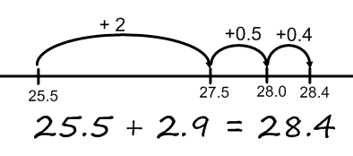  - Children extend their use of the compact column method to add numbers with at least four digits and decimals with careful consideration of missing place holders.  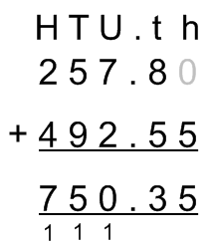  Children may include zero place-holders to aid layout and understanding of place value. | Progression of Calculation  TH H T U – TH H T U  U.t – U.t  U.t h – U.th  U.t h – U.t  U. t – U . t h  Then with larger numbers involving decimals  Written methods  - Where numbers are close together or are close to multiples of 10, 100, etc. children use the empty number line and known facts to bridge through hundreds and thousands and using flexible mental strategies when possible.  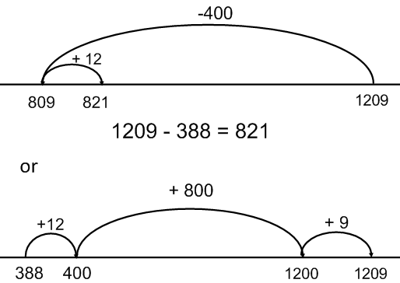 or 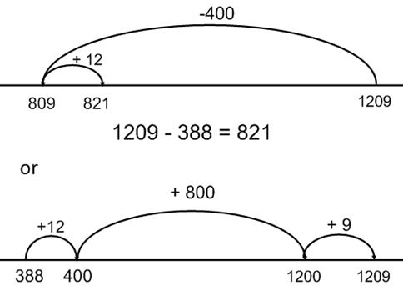  - When confident, children may record their bridging jumps using jottings.  E.g.  1009 – 388  Children may record the red numbers only.  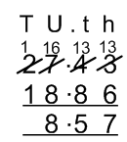  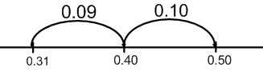  - Empty number line methods are applied to subtracting decimals to support the ordinal aspect of the number system (including bridging through tenths and units).  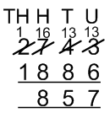  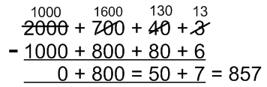  E.g. 0.5 – 0.31 = 0.19  388 + 12= 400  400 +600 = 1000  1000 + 9 = 1009  621  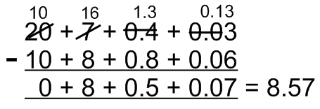
- Children use expanded methods to show understanding of place value up to 1000 and to 2-decimal places before using compact methods.
However, if children have already secured their understanding of place-value and the compact method, they needn’t go back to using expanded methods.

Addition and Subtraction: Year 6
Mental Maths Objectives
Recall | Mental Calculation Skills | Mental Strategies
- sums and differences of decimals, e.g. 6.5 + 2.7, 7.8 – 1.3  - doubles and halves of decimals, e.g. half of 5.6, double 3.4  - what must be added to any four-digit number to make the next multiple of 1000, e.g. 4087 + □ = 5000  - what must be added to a decimal with units and tenths to make the next whole number, e.g. 7.2 + □ = 8 | - add or subtract a pair of two-digit numbers or three-digit multiples of 10, e.g. 38 + 86, 620 – 380, 350+ 360  - add or subtract a near multiple of 10 or 100 to any two-digit or three-digit number, e.g. 235 + 198  - find the difference between near multiples of 100, e.g. 607 – 588, or of 1000, e.g. 6070 – 4087  - add or subtract any pairs of decimal fractions each with units and tenths, e.g. 5.7 + 2.5, 6.3 – 4.8 | - count on or back in hundreds, tens, ones and tenths  - partition: add hundreds, tens or ones separately, then recombine  - subtract by counting up from the smaller to the larger number  - add or subtract a multiple of 10 or 100 and adjust  - partition: double and adjust  - use knowledge of place value and related calculations, e.g. 6.3 – 4.8 using 63 – 48  - partition: count on or back in minutes and hours, bridging through 60 (analogue and digital times)

Addition | Subtraction
Progression of Calculation  Addition of numbers with any number of digits  Addition of two or more numbers with at least 4 digits and 3 decimal places  Addition of two or more numbers with at least 4 digits of various sizes and varied decimal places. (e.g. 401.2 + 26.85 + 13)  Written Methods  - Use empty number lines as for Y3, 4 and 5 and continue to recognise when a written or mental strategy (with or without jottings) is more efficient.  - Confident understanding of place value and use compact column method:  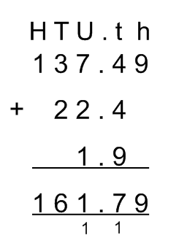 | Progression of Calculation  Refine year 5  Difference between 2 negative integers  Difference between positive and negative integers  Written methods  - In year 6 children will refine methods taught in year 5 to consolidate the compact methods and work with accuracy and fluency.  - Children will use an empty number line to show differences between negative numbers, and positive and negative numbers.  What is the difference between 40 and -35?  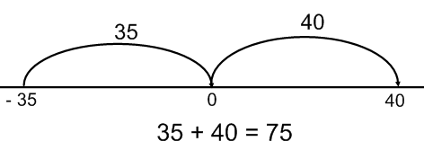

Multiplication and Division: EYFS
Mental Maths Objectives: No guidance available
Recall | Mental Calculation Skills | Mental Strategies

Multiplication | Division
Progression of calculation  Counting in 2s and 10s  Doubling single-digit numbers  Written methods  - Children use practical equipment and pictures to create sets of equal amounts and add together by counting.  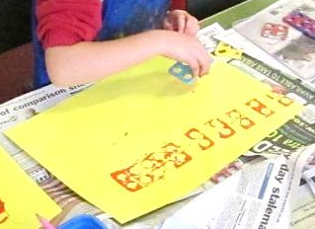  - Children make a record of doubling numbers to 5 using practical equipment, pictures and symbols.  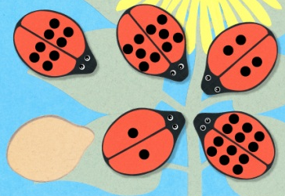  - Through songs, games, real life contexts and using practical equipment, children count in repeated groups of the same size (2s, 10s).  - Children use number lines, number tracks and hundred squares to count in 2s and 10 and notice patterns.  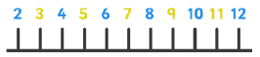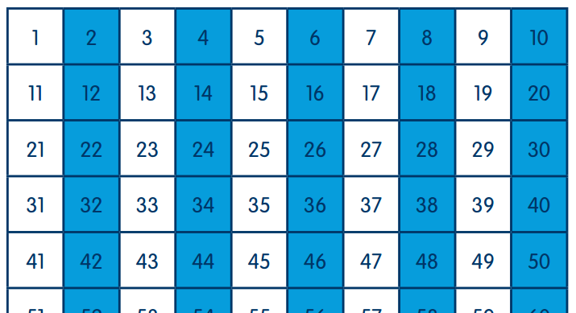 | Progression of calculation  Creating equal groups of a set of objects  Sharing a set of objects  Written methods  - Children use practical materials to create equal groups to solve a problem  E.g. How many cars can be made with 8 wheels?  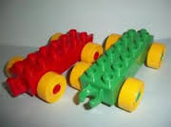  - Through opportunities which arise in the classroom, children share objects equally (this includes sharing into two sets to halve numbers).  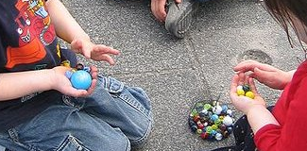  - Children will be encouraged to count out objects in 2s and 10s when grouping and sharing if appropriate.

Multiplication and Division: Year 1

Mental Maths Objectives:
Recall | Mental Calculation Skills | Mental Strategies
- doubles of all numbers to 10, e.g. double 6  - odd and even numbers to 20 | - count on from and back to zero in ones, twos, fives or tens | - use patterns of last digits, e.g. 0 and 5 when counting in fives

Multiplication | Division
Progression of calculation  Doubling of numbers to 10  Multiplication of sets of 2s, 5s, and 10  Written methods  - Children group quantities of small objects and make pictures to show their understanding of multiplications as adding equal sets.  e.g. 4 x 2 = 8; 4 groups of 2 are equal to 8.  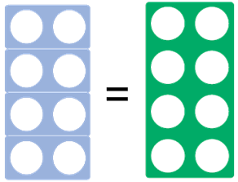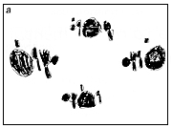  - With support, children begin to represent multiplication sentences as arrays.  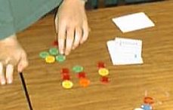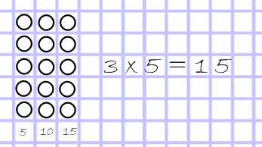  - Children begin to link their knowledge of counting in 2s, 5s and 10s to multiplication situations and use a number line, numicon, number track or hundred square to help them.  - Teacher demonstrates using a number line and hundred-square to record multiplication of 2s, 5s and 10s.  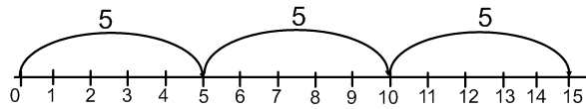 | Progression of calculation  Halving 0 – 20  0-20 ÷ u  Written methods  - Children use physical objects to share equally.  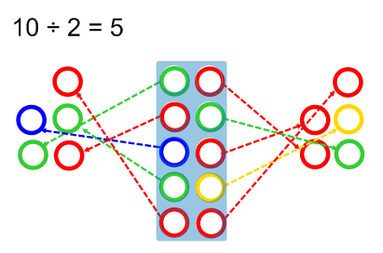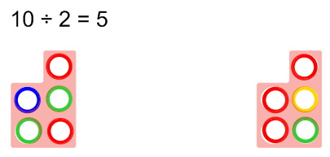  - Children use informal recording to share objects equally into sets.  15 ÷ 5 = 3  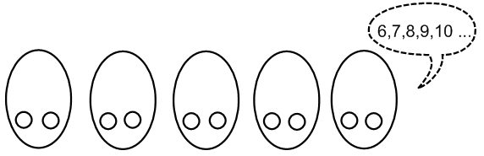  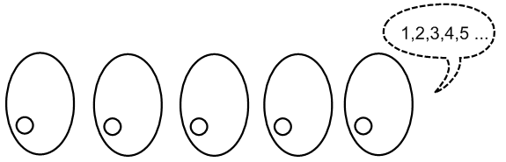  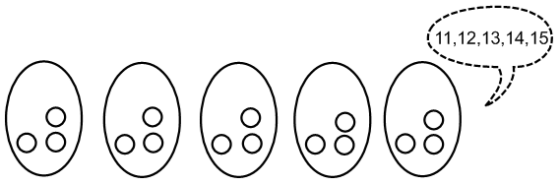  - Children use physical objects to take equal groups away from a given set and count the groups they have made.  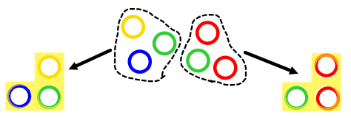

Multiplication and Division: Year 2

Mental Maths Objectives:
Recall | Mental Calculation Skills | Mental Strategies
- doubles of all numbers to 20, e.g. double 13, and corresponding halves  - doubles of multiples of 10 to 50, e.g. double 40, and corresponding halves  - multiplication facts for the 2, 5 and 10 times-tables, and corresponding division facts  - odd and even numbers to 100 | - double any multiple of 5 up to 50, e.g. double 35  - halve any multiple of 10 up to 100, e.g. halve 90  - find half of even numbers to 40  - find the total number of objects when they arethey are organised into groups of 2, 5 or 10 | - partition: double the tens and ones separately, then recombine  - use knowledge that halving is the inverse of doubling and that doubling is equivalent to multiplying by two  - use knowledge of multiplication facts from the 2, 5 and 10 times-tables, e.g. recognise that there are 15 objects altogether because there are three groups of five

Multiplication | Division
Progression of Calculation  U x (2, 5, 10)  Doubles to 20 + 20  Written Methods  - Children will show understanding of multiplication as repeated addition using different language structures. 5 times 3 , 3 groups of 5, 5 multiplied by 3, etc  e.g. 5 x 3 = 5 + 5 + 5  - Repeated addition will be demonstrated using practical equipment (numicon, bead strings, etc) and recorded on a number line.  Children use known facts to progress on to an empty number line.  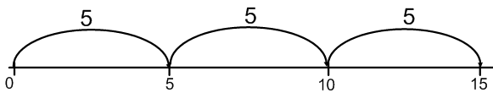  - Children show their understanding of multiplication using arrays and recognise the commutativity of multiplication.  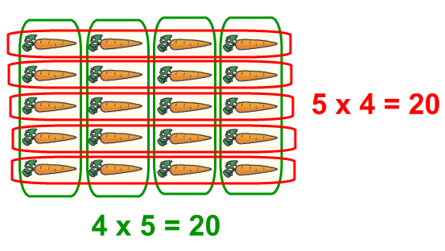 | Progression of Calculation  Halving 0 – 40  TU ÷ U (using jottings and equipment in context)  TU ÷ 2, 5, 10 (using known facts)  TU ÷ 2, 5, 10 with remainders  Written Methods  - Children use jottings and equipment to support their understanding of grouping and sharing (including use of arrays)  e.g.  15 shared between 3 There are 6 sweets, how many people can have 2 sweets each?  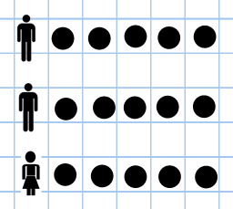    - Children use bead strings, numicon and number lines to represent division as grouping. Children will be given experience of counting on in equal groups (inverse of multiplication) and counting back in equal groups (repeated subtraction). E.g. 15 ÷ 3 = (How many equal groups of 3 are in 15?)  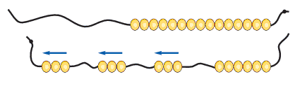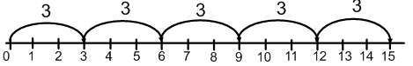  - As children learn facts, they record using an empty numberline.  25 ÷ 5 = 5  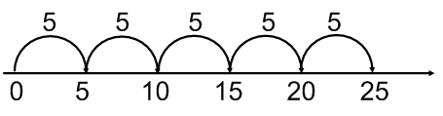or 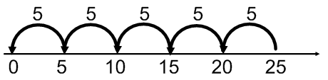  - Children move onto calculations involving remainders with help from arrays and beaded number lines. 27 ÷ 5 = 5 R2 (How many equal groups of 5 are in 27?)  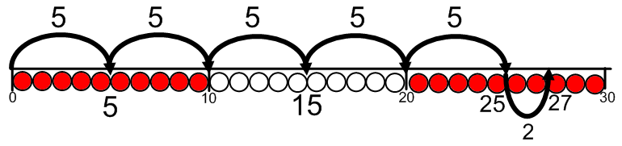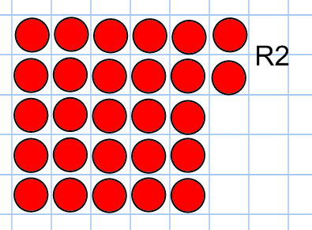

Multiplication and Division: Year 3

Mental Maths Objectives:
Recall | Mental Calculation Skills | Mental Strategies
- multiplication facts for the 2, 3, 4, 5, 6, 8 and 10 times-tables, and corresponding division facts  - doubles of multiples of 10 to 100, e.g. double 90, and corresponding halves | - double any multiple of 5 up to 100, e.g. double 35  - halve any multiple of 10 up to 200, e.g. halve 170  - multiply one-digit or two-digit numbers by 10 or 100, e.g. 7 × 100, 46 × 10, 54 x 100  - find unit fractions of numbers and quantities involving halves, thirds, quarters, fifths and tenths | - partition: when doubling, double the tens and ones separately, then recombine  - partition: when halving, halve the tens and ones separately, then recombine  - use knowledge that halving and doubling are inverse operations  - recognise that finding a unit fraction is equivalent to dividing by the denominator and use knowledge of division facts  - recognise that when multiplying by 10 or 100 the digits move one or two places to the left and zero is used as a place holder

Multiplication | Division
Progression of Calculation  U x (2, 3, 4, 5, 8, 10)  (1-20) x (2, 3, 4, 5, 8, 10) - beyond 20 when confident.  Multiply 1- or 2-digit numbers by 10 and 100  Written Methods  - Children will continue to use the empty number line and/or arrays to reinforce the application of known facts. E.g.  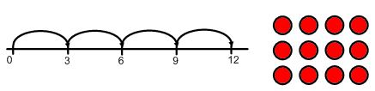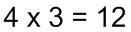  - Arrays will be used to support with learning the associative rule of multiplication and used to learn new facts. e.g.  8 x 7 = (4 x 7) +( 4 x 7) = 28 + 28 = 56  - Children continue to use and make partitioned arrays to multiply larger numbers.  An ‘L-shaped’ cover can be placed on top to create arrays of any size. The size of the grid can be increased according to confidence.  Children can record using an empty number line.  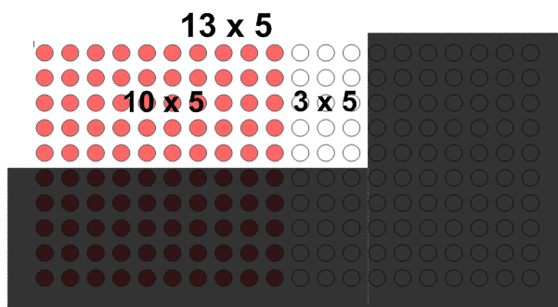  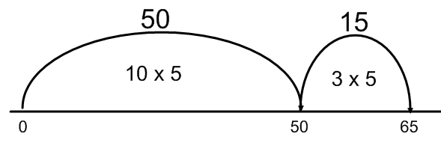  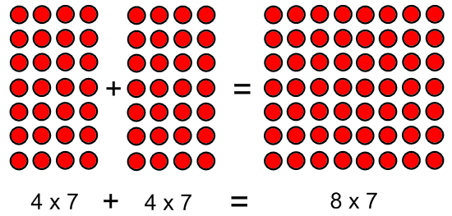  - When confident, children can record using an informal partitioning method.  e.g. 28 x 5 = (10 x 5) + (10 x 5) + (8 x 5)  = 50 + 50 + 40 = 140  Leading to: 28 x 5 = (20 x 5) + (8 x 5)  = 100 + 40 = 40 | Progression of Calculation  TU ÷ (2, 3, 4, 5, 8, 10) – answers between 0 and10.  TU ÷ (2, 3, 4, 5, 8, 10) – answers between 1 and 10 with remainders.  Written Methods  - Children will use an empty number lines and arrays to support their calculations and the learning of new facts.  e.g. 24 ÷ 4 = 6  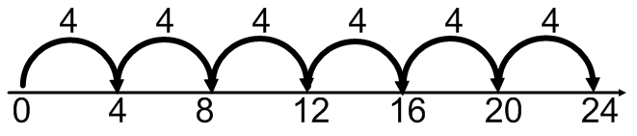  - Children will use empty number lines to answer questions with remainders. Children should be allowed to jump forward or backwards along the line according familiarity of times tables and efficiency. 27 ÷ 5 =  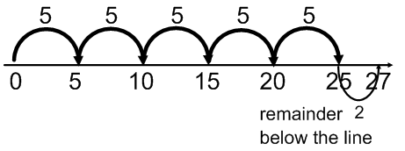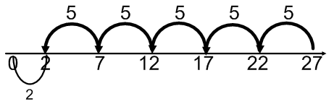  - Children will use known facts or arrays to represent and answer missing number calculations. E.g. 24 ÷ = 6 (6 equal groups of “something” are in 24)  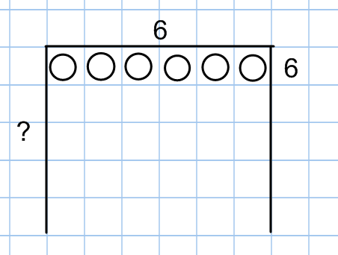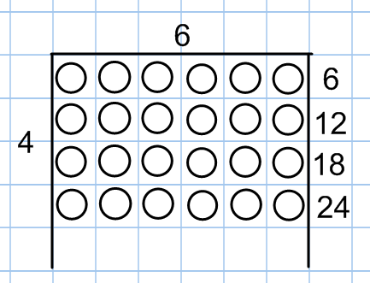
Multiplication and Division: Year 4
Mental Maths Objectives:
Recall | Mental Calculation Skills | Mental Strategies
- multiplication facts to 12 × 12 and the corresponding division facts  - doubles of numbers 1 to 100, e.g. double 58, and corresponding halves  - doubles of multiples of 10 and 100 and corresponding halves  - fraction and decimal equivalents of one-half, quarters, tenths and hundredths, e.g. 310 is 0.3 and 3100 is 0.03  - factor pairs for known multiplication facts | - double any two-digit number, e.g. double 39  - double any multiple of 10 or 100, e.g. double 340, double 800, and halve the corresponding multiples of 10 and 100  - halve any even number to 200  - find unit fractions and simple non-unit fractions of numbers and quantities,  e.g. 3/8 of 24  - multiply and divide numbers to 1000 by 10 and then 100 (whole-number answers), e.g. 325 × 10, 42 × 100, 120 ÷ 10, 600 ÷ 100, 850 ÷ 10  - multiply a multiple of 10 to 100 by a single-digit number, e.g. 40 × 3  - multiply numbers to 20 by a single-digit, e.g. 17 × 3  - identify the remainder when dividing by 2, 5 or 10  - give the factor pair associated with a multiplication fact, e.g. identify that if 2 x 3 = 6 then 6 has the factor pair 2 and 3 | - partition: double or halve the tens and ones separately, then recombine  - use understanding that when a number is multiplied or divided by 10 or 100, its digits move one or two places to the left or the right and zero is used as a place holder  - use knowledge of multiplication facts and place value, e.g. 7 x 8 = 56 to find 70 x 8, 7 x 80 = 560  - use partitioning and the distributive law to multiply, e.g.  13 × 4 = (10 + 3) × 4  = (10 × 4) + (3 × 4)  = 40 + 12 = 52

Multiplication | Division
Progression of Calculation  U X TU (grid)  U x TU (expanded column)  Multiplication of numbers by 10, 100, 1000  Written methods  - Children will continue to and arrays, where appropriate, leading to the grid method for multiplication: e.g. 23 x 6  Children will estimate first: e.g. 20 x 6 = 120  Children may calculate each group of 10 separately until confident to do this in one step.  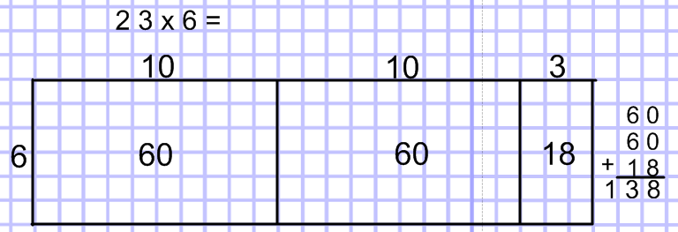  Proportional grid size is conserved until children are ready for more abstract recording.  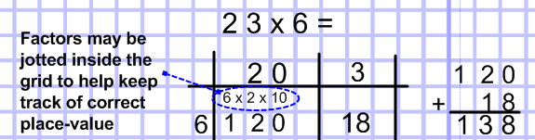  - Only if ready, children can learn to transfer their understanding of the grid method to expanded column.  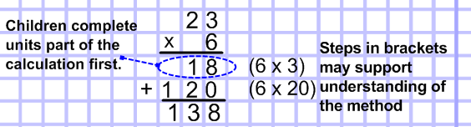 | Progression of Calculation  TU ÷ U = answers 0 – 10  TU ÷ U = answers greater than 10.  As above including remainders.  Written methods  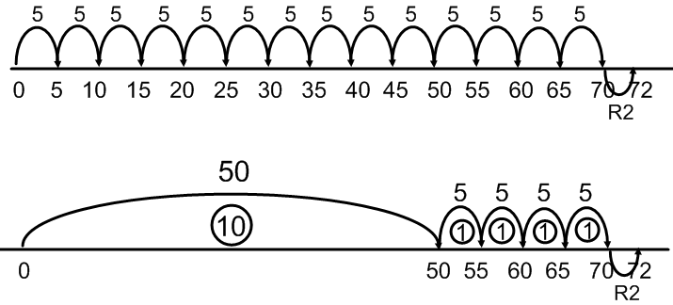  - Children continue to use the empty number line but begin to apply known facts to jump in multiples of the divisor. These should be multiples of 10s, 5s, 2s and 2s – numbers with which the children are more familiar. E.g. 72 ÷ 5 = 14 R2  - Children will use a grid method layout to partition the dividend into multiples of the divisor. Emphasis will be placed on partitioning multiples of 10 and those which are subtracted easily. Explicit links will be made to multiplication.  e.g. 64 ÷ 4 = 16  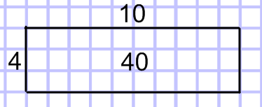 then 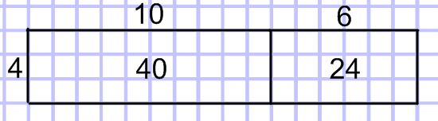  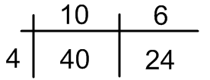  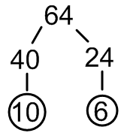  - With increasing confidence, children are encouraged to develop quick informal methods of recording their partitioning.  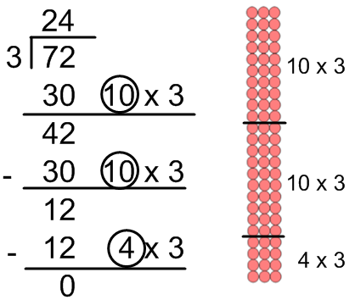  - For larger/more difficult numbers, children will record their working out vertically using chunking and column subtraction. E.g. 72 ÷ 3 = 24  With confidence, children will combine multiples of 10 to make larger chunks (i.e. 20 x 3).  (An array can aid understanding)
Multiplication and Division: Year 5
Mental Maths Objectives:
Recall | Mental Calculation Skills |  | Mental Strategies
- squares to 12 × 12  - division facts corresponding to tables up to 10 × 10, and the related unit fractions, e.g. 7 × 9 = 63 so one-ninth of 63 is 7 and one-seventh of 63 is 9  - percentage equivalents of one-half, one-quarter, three-quarters, tenths and hundredths  - factor pairs to 100 | - multiply and divide two-digit numbers by 4 or 8, e.g. 26 × 4, 96 ÷ 8  - multiply two-digit numbers by 5 or 20, e.g. 320 × 5, 14 × 20  - multiply by 25 or 50, e.g. 48 × 25, 32 × 50  - double three-digit multiples of 10 to 500, e.g. 380 × 2, and find the corresponding halves, e.g. 760 ÷ 2  - find the remainder after dividing a two-digit number by a single-digit number, e.g. 27 ÷ 4 = 6 R 3  - multiply and divide whole numbers and decimals by 10, 100 or 1000, e.g. 4.3 × 10, 0.75 × 100, 25 ÷ 10, 673 ÷ 100, 74 ÷ 100  - multiply pairs of multiples of 10, e.g. 60 × 30, and a multiple of 100 by a single digit number, e.g. 900 × 8  - divide a multiple of 10 by a single-digit number (whole number answers) e.g. 80 ÷ 4, 270 ÷ 3  - find fractions of whole numbers or quantities, e.g.  2/3 of 27, 4/5 of 70 kg  - find 50%, 25% or 10% of whole numbers or quantities, e.g. 25% of 20 kg, 10% of £80  - find factor pairs for numbers to 100, e.g. 30 has the factor pairs 1 × 30, 2 × 15, 3 × 10 and 5 × 6 |  | - multiply or divide by 4 or 8 by repeated doubling or halving  - form an equivalent calculation, e.g. to multiply by 5, multiply by 10, then halve; to multiply by 20, double, then multiply by 10  - use knowledge of doubles/halves and understanding of place value, e.g. when multiplying by 50 multiply by 100 and divide by 2  - use knowledge of division facts, e.g. when carrying out a division to find a remainder  - use understanding that when a number is multiplied or divided by 10 or 100, its digits move one or two places to the left or the right relative to the decimal point, and zero is used as a place holder  - use knowledge of multiplication and division facts and understanding of place value, e.g. when calculating with multiples of 10  - use knowledge of equivalence between fractions and percentages, e.g. to find 50%, 25% and 10%  - use knowledge of multiplication and division facts to find factor pairs
Multiplication |  | Division
Progression of Calculation  HTU x U  TU x TU  U x U.t  Written methods  - Grid method will continue to be used to support understanding of short multiplication and long multiplication.  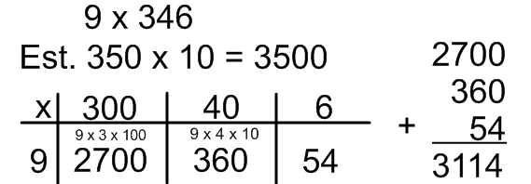  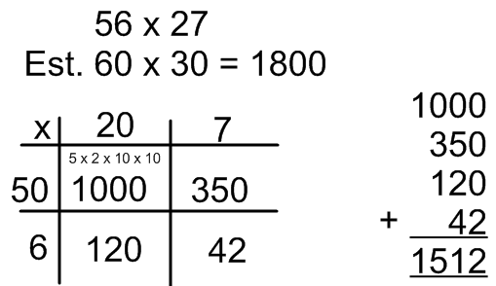  - Children will transfer their understanding to the expanded column method (maintaining links to the grid method).  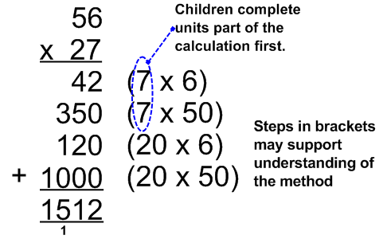  - Children will use the grid method to multiply numbers with 1 decimal-place.  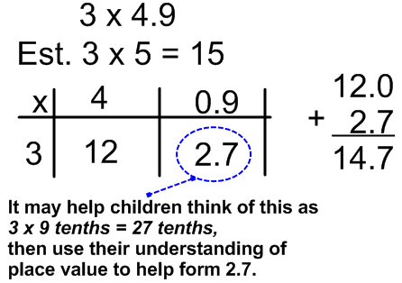 |  | Progression of Calculation  TU ÷ U  HTU ÷ U = TU  HTU ÷ U = HTU  THTU ÷ U =  As above with remainders.  Written methods  - Children continue to use chunking (vertical repeated subtraction) to divide larger numbers with increasing efficiency.  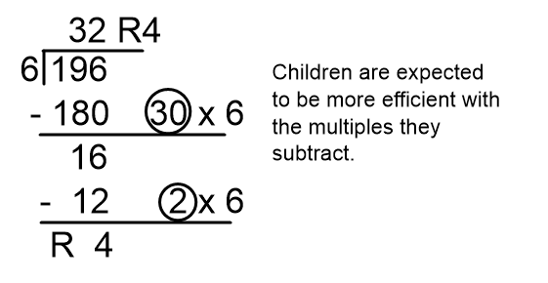  - Where appropriate, children will also be encouraged to use partitioning methods (depending on mental subtraction skills).  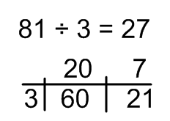  - The children will use an expanded method of the formal algorithm before the teacher demonstrates the short method. E.g. 792 ÷ 6 = 132  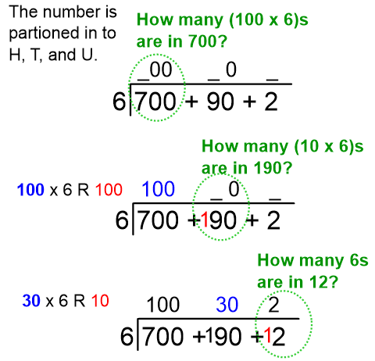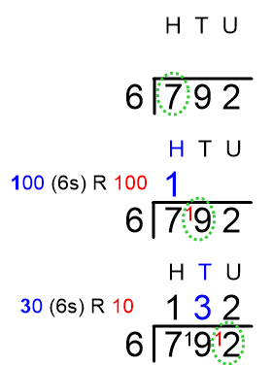  - If confident, children use the short algorithm to divide TU by U, then HTU by U.
Multiplication and Division: Year 6
Mental Maths Objectives:
Recall | Mental Calculation Skills |  | Mental Strategies
- squares to 15 × 15  - squares of the corresponding multiples of 10  - prime numbers less than 100  - equivalent fractions, decimals and percentages for hundredths, e.g. 35% is equivalent to 0.35 or 35/100  - factor pairs to 1000 | - multiply pairs of two-digit and single-digit numbers, e.g. 28 × 3  - divide a two-digit number by a single-digit number, e.g. 68 ÷ 4  - divide by 25 or 50, e.g. 480 ÷ 25, 3200 ÷ 50  - double decimals with units and tenths, e.g. double 7.6, and find the corresponding halves, e.g. half of 15.2  - multiply pairs of multiples of 10 and 100, e.g. 50 × 30, 600 × 20  - divide multiples of 100 by a multiple of 10 or 100 (whole number answers), e.g. 600 ÷ 20, 800 ÷ 400, 2100 ÷ 300  - multiply and divide two-digit decimals such as 0.8 × 7, 4.8 ÷ 6  - find 5% or multiples of 5%, of whole numbers and quantities, e.g. 35% of 50 ml, 15% of £30, 45% of 200 g  - simplify fractions by cancelling  - scale up and down using known facts, e.g. given that three oranges cost 24p, find the cost of four oranges  - identify numbers with odd and even numbers of factors and no factor pairs other than 1 and themselves |  | - partition: use partitioning and the distributive law to divide tens and ones separately, e.g.  92 ÷ 4 = (80 + 12) ÷ 4  = 20 + 3 = 23  - form an equivalent calculation, e.g. to divide by 25, divide by 100, then multiply by 4; to divide by 50, divide by 100, then double  - use knowledge of the equivalence between fractions and percentages and the relationship between fractions and division  - recognise how to scale up or down using multiplication and division, e.g. if three oranges cost 24p:  one orange costs 24 ÷ 3 = 8p  four oranges cost 8 × 4 = 32p  - Use knowledge of multiplication and division facts to identify factor pairs and numberswith only two factors
Multiplication |  | Division
Progression of Calculation  TH H T U x U  H T U x T U  U x U. t h  Written methods  - Children will continue to use grid method to maintain understanding of place value when multiplying larger numbers and understanding the process of finding partial products. E.g.  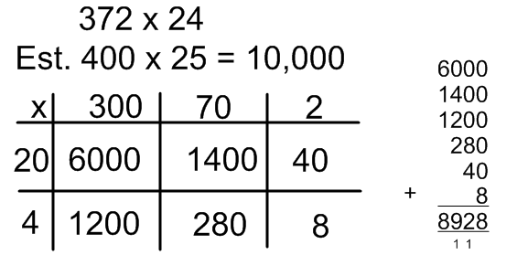  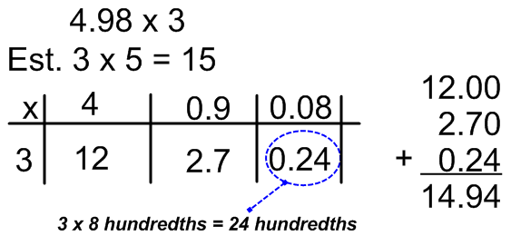  - Children will move on to setting out their partial products in expanded column method.  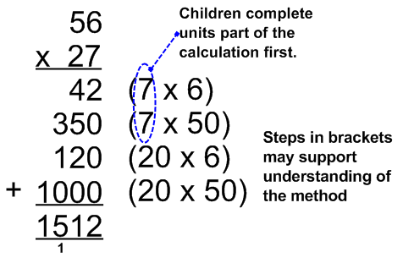 |  | Progression of Calculation  THTU ÷ U (with decimal and fraction remainders, depending on context).  HTU ÷ TU  THTU ÷ TU  U.t ÷ U  TU.t ÷ U  Written methods  - Year 5 formal and informal methods for short division will be consolidated. Additionally, remainders will be expressed either as a fraction of the divisor or as a decimal.  - Children will use chunking as their main/reliable method for long division.  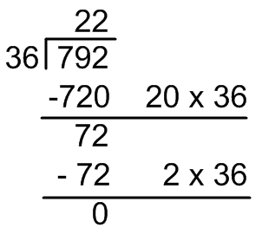  - If confident, children use the formal algorithm.  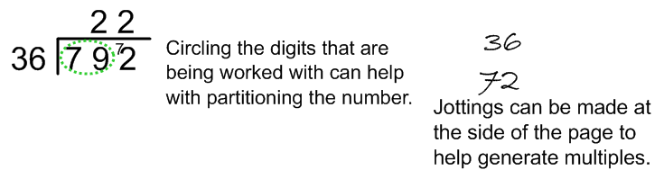  - Children use chunking to divide numbers with one decimal place by a single digit number.  

