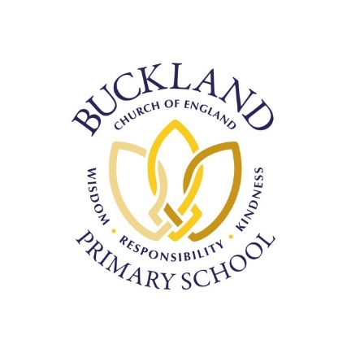
Newsletter Term 1 Number 8 Thursday 23rd October 2025
Values of the term: Belief, Trust, Respect
‘When we plant trees, we plant the seeds of peace and hope’ - Wangari Maathai

Dear all,
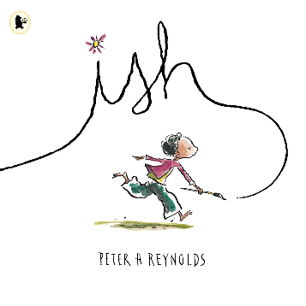
This week in our Monday worship, we shared the book ‘ish’ by Peter Reynolds – a lovely story about embracing creativity and self-expression. The story is about Ramon, a young boy who learns that things don’t have to be ‘perfect’ to be wonderful. We talked about how it’s important not to put too much pressure on ourselves, but instead to enjoy our learning and do our best – to be brave and give it a go!

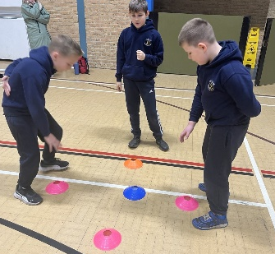
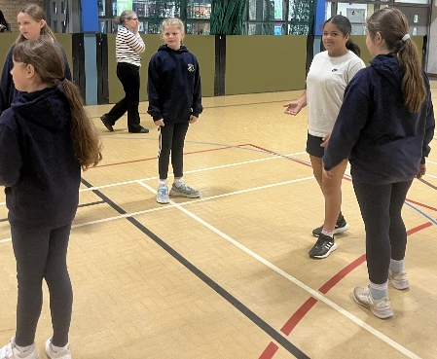
Playleaders - A group of our Year 5 and 6 children visited FCC this week to take part in Playleader training. During the session, they learned how to organise fun and inclusive games, encourage teamwork, and help younger pupils enjoy active playtimes. The children showed great enthusiasm and maturity throughout the morning. We are very proud of how they represented our school and can’t wait to see them putting their new skills into action on the playground.

This week in classes -
Acorns - have continued to enjoy learning about different people in our community this week. We have shared lots of stories about different families and have been noticing similarities and differences between our own and other families. We have also been learning about how people prepare for and celebrate Diwali. The children have been creating their own rangoli patterns and Diwali crafts.

Beech - This week, Beech have been learning about taking away within 20 in Maths. They have also recapped doubles and near doubles. In English, we have been writing a story based on chapter 27 in Harry the Poisonous centipede. We imagined what it would feel like to have a centipede in our mouths and thought of some brilliant adjectives to describe it! In RE this term, we have been learning about Christianity, and our Big Question has been 'Who made the World?' This week, we painted a picture of the world that we think God would have imagined when he created it. In IT, we have been learning how to use the iPad correctly to find the right app- this is really important to keep us safe.

Sycamore - have had a busy and exciting week of learning! In English, we’ve been diving into the book The Explorer. The children brought the story to life with fantastic performances, acting out scenes of rainforest adventures inspired by the text. In Maths, we’ve been working hard on column subtraction with 3- and 4-digit numbers, showing great focus and resilience. Our Science lessons have been hands-on as we carried out a fair test experiment to explore different types of soil and their properties. In PE, we enjoyed some lively netball matches, practising our teamwork, coordination, and communication skills. It’s been a brilliant half term - well done, Sycamore Class! Have a wonderful and well-deserved half-term break.

Oak - have been writing their recounts of Wayland's Smithy into their portfolio books. As well as reading Wolf Brother, we have also read texts based on diversity. In Maths, we have continued to focus on Fractions. The Y5s have been adding and subtracting fractions with different denominators whilst the Y6s have been adding and subtracting mixed numbers. We have had some excellent intra school Tag Rugby matches on the top field this week. Creating fact files about Charles Darwin and Alfred Wallace has been our focus in Science. In RE, we have developed the children's understanding of Islam and in particular the importance of Muhammad (PBUH) to Muslims.

Poppy Appeal – Year 6 pupils are selling Poppy Appeal items at the school gate. All donations are welcome to support this important cause - cash only.

Week after half term -
Monday – Inset day – no children in school
Tuesday – First day of Term 2
Wednesday – Hooke Court info in Sycamore class 3.30pm

James’s bake sale
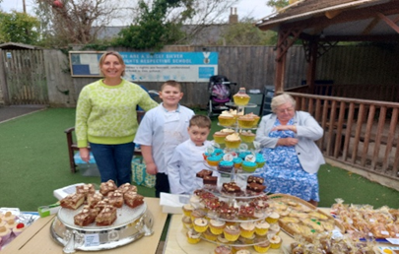
A big thank you to everyone who supported James’s cake sale. James has raised a total of £791.50. All the money raised is going to Rosies Rainbow Fund. James is the first ever young ambassador for this charity. James has raised over £2500 for this charity in a year - an extraordinary achievement!
https://www.rosiesrainbowfund.co.uk/

Christmas Card competition – message from Thames valley Police –
We would like to invite children to take part in a special creative project for the official 2025 Thames Valley Police Christmas card, which will be sent out by our Chief Constable to police forces and partners across the country. The theme is “Festive Policing” and we’re encouraging children to be as imaginative and creative as they like. This could include anything from police officers helping Santa, festive patrol scenes, or snowy police stations decorated for the season. Please try to avoid anything too graphic though.

Artwork should be created on an A4 page and use bold, vibrant colours to help it stand out. Any medium is welcome - paint, crayons, pencils, collage, or digital art. The deadline for artwork submissions is 31 October. Please give physical copies of your submissions to the school office and we will pass them on to our Thames Valley Police Schools Officer. Please include your child’s name and school details on the back.

Selected artwork will be featured on the official Christmas card, and the winning student(s) will be acknowledged in our internal communications and social media. Thank you for supporting this initiative - we’re looking forward to seeing the festive creativity your pupils bring to life.
Best wishes,
The Thames Valley Police Corporate Communications Team

Achievements
House | Horse | Ox | Dragon
Weekly total | 33 | 55 | 36
Termly total | 421 | 632 | 536

Have a lovely half term break – see you all back at school on Tuesday 4th November.

Mrs Brown and the Buckland Team.

